The Primary Care Trigger Tool:
Practical Guidance
Reviewing patient records to detect and reduce patient safety incidents

Index

Content Page

Introduction 2
What is a ‘trigger tool’? 2
Key points for reviewers and teams 2
Summary of the trigger tool process 3

Step one: planning and preparation 4

Step two: systematic review of records 6

Step three: reflection and further action 7

Appendix

- The trigger tool process (flowchart)

- The trigger tool data collection proforma

- How to complete the Summary Report

Introduction

Summary
- Trigger review provides the GP team with important opportunities to identify patient safety-related incidents, individual and team learning needs and provide focus for improvement activity.
- By screening small samples of the records of high risk groups of patients, the team can detect and learn from ‘incidents’ or ‘latent risks’ that may be hidden in the records.
- A typical review lasts about 2-3 hours which enables you to screen 25 records and reflect on the findings.
- The focus is on identifying avoidable harm or other patient safety incidents of interest, not individual errors.
- Harm or a patient safety incident is defined as:

“Any incident that caused harm, or could have caused harm to a patient as a result of their interaction with health care”

What is Trigger Review?
- Trigger review is simply a method of audit that involves the systematic evaluation of a small batch of patient records by a clinician (usually a GP or a Nurse)
- A ‘Trigger’ is a pre-defined prompt or sign in the record that MAY indicate that a patient safety incident has occurred – roughly defined as any incident, however minor, where a patient was harmed or may have been
(a near miss).

For example an eGFR reduction >5 would be a ‘‘trigger’’ for the reviewer to undertake a more focused examination of the record for evidence of acute kidney injury and its cause.
- Once a trigger(s) is detected this is a signal for the reviewer to undertake a more in-depth review of the record to determine if evidence of a safety incident exists.
- If a safety incident is uncovered, the reviewer makes a professional judgement on whether it was avoidable or not, how severe it was and if it originated in primary care or elsewhere.
- This helps the team to pinpoint those incidents where learning and improvement are a greater priority to focus improvement activity.

Why is it Important?
- Currently safety incidents are reported by patients, identified directly by clinicians or highlighted by colleagues as part of routine practice. However, some incident types are not detected so easily.
- Systematically reviewing medical records for previously undetected incidents and threats can provide the care team with a whole new perspective on patient safety.
- It also offers valuable opportunities to take PRE-EMPTIVE action before harm can occur or pinpoint learning needs where patient safety was avoidably compromised.

What Types of Patient Safety Incidents Are Found?
- The types of safety incidents and risks typically uncovered tend to differ in general terms from those highlighted by complaints, significant event analyses and other methods. Some examples are illustrated in the table below.

Preventable Safety Incidents | Elderly housebound patient admitted to hospital with a fragility fracture after several accidental falls. Hypotension from multiple antihypertensive agents was implicated. No contact with any practice team member for seven years previously. | Allergy not coded
Preventable Safety Incidents | Patient prescribed Warfarin presented with symptomatic anaemia. INR was therapeutic and had been checked regularly but his haemoglobin had not been checked during the previous three years. | Co-prescribed multiple drugs – counteracting/ unnecessary
Preventable Safety Incidents | Patient admitted as a hospital emergency and found to have hyperkalaemia. Further review found that a blood sample two weeks before had been reported as haemolyzed but that the test had not been repeated | Follow-up/Referral didn’t happen
Preventable Safety Incidents | Patient re-consulted with an allergic reaction to a prescribed antibiotic. Further review found a similar incident years before that had not been coded. | Not stopping medication that should have been stopped

Summary of the trigger tool process

The process can be simplified into three main steps:

STEP 1: Planning and preparation

STEP 2: Review a random sample of records

STEP 3: Reflection and further action.

The process is flexible and can be adapted according to the improvement aims of individual clinicians and primary care teams.

Step one: Planning and preparation

Sampling medical records

Which records should be chosen?

Patients’ susceptibility to patient safety incidents vary widely and are influenced by many factors, including age, frequency of consultation, co-morbidities and the number and types of prescribed medications.
The rationale for choosing a specific sub-population of patient records to review is that it increases the likelihood of detecting patient safety incidents. There is no single ‘right’ group to choose. In practice, the selected patient groups will mainly depend on the reviewers’ preference and review aims.

Below are some examples of populations to review

EXAMPLES OF POTENTIAL PATIENT SUB-POPULATIONS TO AUDIT

- Specific, shared patient characteristics | - Chronic Disease Areas | - High Risk Medications
Nursing Home Patients | Chronic obstructive pulmonary disease | Insulin
Older than 75 years | Stroke or transient ischaemic attack | Morphine/ Opiates
Recent hospital admissions | Cardiovascular disease | Warfarin
Recent falls | Diabetes | Methotrexate/ Azathioprine
Patients requiring emergency home visit | Heart failure | Non-steroidal anti-inflammatory drugs (NSAIDs)
On district nursing caseload | Chronic Kidney Disease | Diuretics (x2)
Last 25 out-of-hours attendees | Dementia | More than 5 repeat medication items
Last 25 hospital referrals |  | On dosette boxes/ weekly dispensing
 |  | Anticonvulsants
 |  | Antipsychotics
- Combinations of Groups 1 to 3

e.g. Patients over 75 years, taking 5 or more medications, who had an emergency home visit attended in previous 12-weeks; nursing home patients prescribed non-steroidal anti-inflammatory drugs, or patients with heart failure and who are prescribed 2 or more diuretics.

- Choose Your Own Sub-Populations

e.g. Patients discharged after emergency hospital admission (review the period before and after admission), a random selection of any 25 patients requesting an urgent appointment.

How many records should be reviewed?

Practical experience suggests that it is feasible to review up to 25 records in a two to three hour session. The clinician or practice can choose the specific number depending on their aim. You may need to choose more than one population to have the required number patient records to review.

Medical records from the target group should be selected randomly

What period of time will be reviewed in each record?

We recommend reviewing three consecutive calendar months in every record.

Consider reviewing the period between 4 months and 1 month prior to the review date.

- How long should it take ?

25 records should take between 2 – 3 hours to review.

The maximum time that should be spent on reviewing any one record should be twenty minutes.

It is suggested that once you have detected 5 patient safety incidents then you should stop your case note review and reflection and discuss your findings as a team.

Who should be involved?

The whole team

Administrative staff may play a key role in providing important practical support when applying the trigger tool. They may help in generating list of records, selecting relevant samples, undertaking initial completion of data proformas and entering collected data into a spreadsheet.

The GP and practice nurse are then able review the records for triggers and harm to jointly discuss detected events and describe the characteristics of the patient safety incident.
The whole team should be involved in reflecting on the results, helping to prioritize events and in planning and implementing improvement.

Step two: Systematic review of records

Every record in the random sample is reviewed consecutively. A maximum of 20 minutes review time should be allowed for every record. Reviewers should move on to the next record if they cannot finish in the allotted time. This is quite rare for experienced reviewers who typically require only a few minutes per record. The data to be extracted from each record should be entered onto a proforma (Appendix 2).

Looking for Triggers

Review a 3 month period in each of the patients’ records looking for the triggers below.
Consider reviewing the period between 4 months and 1 month prior to the review date.

Practical tips about ‘triggers’

It is quite possible for a single patient record to generate multiple triggers, or indeed the same trigger may come up more than once, e.g. two hospital admissions during the three month review period. On the record sheet, please keep a tally for each trigger every time it is detected in each record. We are collecting data on the frequency of triggers in order to better understand how commonly these events occur. The triggers do not necessarily represent patient safety incidents; they merely indicate that one may have occurred and should alert you to look in more detail at that part of the record. With a little practice most reviewers very quickly develop their own ‘system’ to screen their electronic health records to detect these triggers. It is helpful to review sections of the clinical record in a systematic manner.
- A trigger is not evidence of harm but a sign that a patient safety incident is more likely to have occurred.
- Once a trigger(s) is detected this is a signal for the reviewer to undertake a more in-depth review of the record to determine if evidence of a patient safety incident exists.

Explanation of the ‘Triggers”

‘≥3 consultations in 7 days’ | Refers to the frequency of contact between a patient and her/his practice. Consultations may be face-to-face, home visits or by telephone and may take place with any member of the practice team.
‘New high priority read code added’ | Refers to any computer code added during the period of review considered to be a ‘priority’. For example, in VISION software it would include any ‘new problem’ or a ‘priority 1’ code.
‘New allergy read code added’ | Refers to any allergy coded during the period of review. This trigger is similar to ‘9’, but is considered separately because most software packages have a dedicated section for these kinds of codes.
Repeat medication item discontinued’ | Refers to any prescribed item discontinued during the period of review
‘Out of hours/A&E attendance’ | Refers to any out of hours or Accident & Emergency attendance by a patient during the period of review
‘Hospital admission’ | Refers to any unplanned (e.g. emergency admission) or planned admission (e.g. elective surgery) for at least 24 hours during the period of review. The admission correspondence and the period just before and after the admission should be screened for the presence of potential patient safety incidents.
‘Hb <10.0’ | Refers to a haemoglobin of < 10.0 g/dl recorded during the period of review. It is a prompt to consider the possibility of a patient safety incident and general care of a patient and does not by itself signify error or harm.
‘eGFR reduction ≥5’ | Prompts the reviewer to screen the record for the presence of an eGFR measure recorded during the review period. If a reduction is indicated, screen the record for additional information to determine if a patient safety incident has occurred.
Optional trigger | There is no ‘correct’ number of triggers. The nature and type of pre-defined triggers are determined by the reviewer. Additional triggers may be added for the purposes of the review. For example, if the reviewer decides to review a sample of patients prescribed Warfarin the she/he may have specified a further trigger ‘INR >5

Can triggers be detected? – if so look for a patient safety incident

If yes, detected triggers should prompt the reviewer to examine the relevant section of the record in more detail to determine if a patient safety incident occurred. Remember the definition of a patient safety incident is:

“Any incident that caused harm, or could have caused harm to a patient as a result of their interaction with health care”

The majority of detected triggers will not be linked to a patient safety incident. In some instances more than one trigger may help to detect the same patient safety incident.

Did a patient safety incident occur?

Patient Safety Incidents (PSIs)

PSIs include ‘near misses’, incidents with the potential for harm as well as actual harm. It is the preferred term and includes other terms such as ‘adverse incident’ and ‘adverse event’. In other words, PSIs are essentially anything that you would not want to happen to a patient that might be the responsibility of the healthcare system. Reviewers sometimes detect PSIs incidentally while reviewing records, without any apparent link to a trigger. For example, missed monitoring opportunities for existing medications found when reviewing records for a ‘new repeat medicine’ trigger. This is completely acceptable and the PSI should still be recorded. Remember, the aim of the trigger review method is to find previously unknown and/or undetected PSIs. The triggers are only a means to this end. Sometimes you have to think creatively to recognise a PSI.

What if you ‘find nothing’ in the review, despite applying the method correctly? This does occur in around 10% of trigger reviews. However, it would be very unusual for this to happen with each and every review you do. Some would argue that you didn’t find ‘nothing’, but that you found evidence of safe, high quality care.

Priority scoring

Once you have identified a PSI then you need to assess its priority to help you prioritise the order in which the patient safety incidents may be considered for action. This is obtained by calculating the severity scale of the incident (between 1-4) and adding it to the preventability scale (between 1-4). Incidents with higher priority scores should arguably be considered first, although this remains at the discretion of the reviewer. Remember that the severity and preventability judgements and scores are subjective.

Severity Scale: |  |  |  |  | Preventability Scale:
Any incident with the potential to cause harm |  | 1 |  | Not preventable and originated in secondary care
Mild harm: inconvenience, further follow-up or investigation to ensure no harm occurred. |  | 2 |  | Preventable and originated in secondary care OR not preventable and originated in primary care
Moderate harm: required intervention or duration for longer than a day |  | 3 |  | Potentially preventable and originated in primary care
Prolonged, substantial or permanent harm, including hospitalization |  | 4 |  | Preventable and originated in primary care

Step three: Reflection and further action to make care safer
The most important part of the trigger tool review process is reflecting on and discussing the results and deciding what action needs to be taken.
The clinician or practice team can use the review process and results in a number of ways. Some of the possible actions are described in more detail below:

Immediate actions/improvements

- With regard to those patients where the PSI was detected - there may still be an opportunity to intervene to prevent further progression or alleviate complications

It may be possible through early, targeted intervention to prevent similar PSIs occurring to other patients

Two examples: a reviewer may have detected a female patient with severe migraine attacks thought to be complicated by the combined hormonal contraceptive pill or the reviewer found a case of Warfarin and Aspirin being co-prescribed. In both these cases the patient may be recalled for a review of their treatment.

Reflection and Opportunities for improvement and collective learning

The clinician or practice team should share and collectively reflect on the review findings as part of routine educational or business meetings. We recommend including every practice team member whenever possible, including those that did not participate in the process. This may help to identify individual or practice-based learning needs which require to be addressed in the short or medium term as well as provide a forum to discuss what went wrong and identify actions that need to be taken to prevent the patient incident recurring.

An example of the educational application of the trigger tool:

A GP trainee detects a case where an elderly patient’s INR temporarily increases to > 5 after prescription of an oral antibiotic for a suspected urinary tract infection. The learning point that patients prescribed anticoagulants require more intensive monitoring during illness is shared with clinical team members during the practice meeting.

Preventing and reducing Patient Safety Incidents and harm

The reviewer or team should consider how they can prevent or reduce harm and improve quality of care.

For example a patient was given an antibiotic and had an adverse drug reaction to it. It transpired that the patient had previously been given the antibiotic and had a similar reaction but this had not been coded. A discussion took place and agreement that all adverse drug reactions should be recorded and not just allergic reactions

Different improvement methodologies are available include Significant Event Analysis, clinical audit and PDSA cycle which may be considered by their practice team to analyse the incident further and or make improvements

Sharing and reporting the findings
It may also be useful and necessary to share specific findings with relevant stakeholders, for example:

- Other general medical practices
Secondary care
Some events may have to be reported through the appropriate local or national reporting systems.

Appendix 1: The trigger tool process

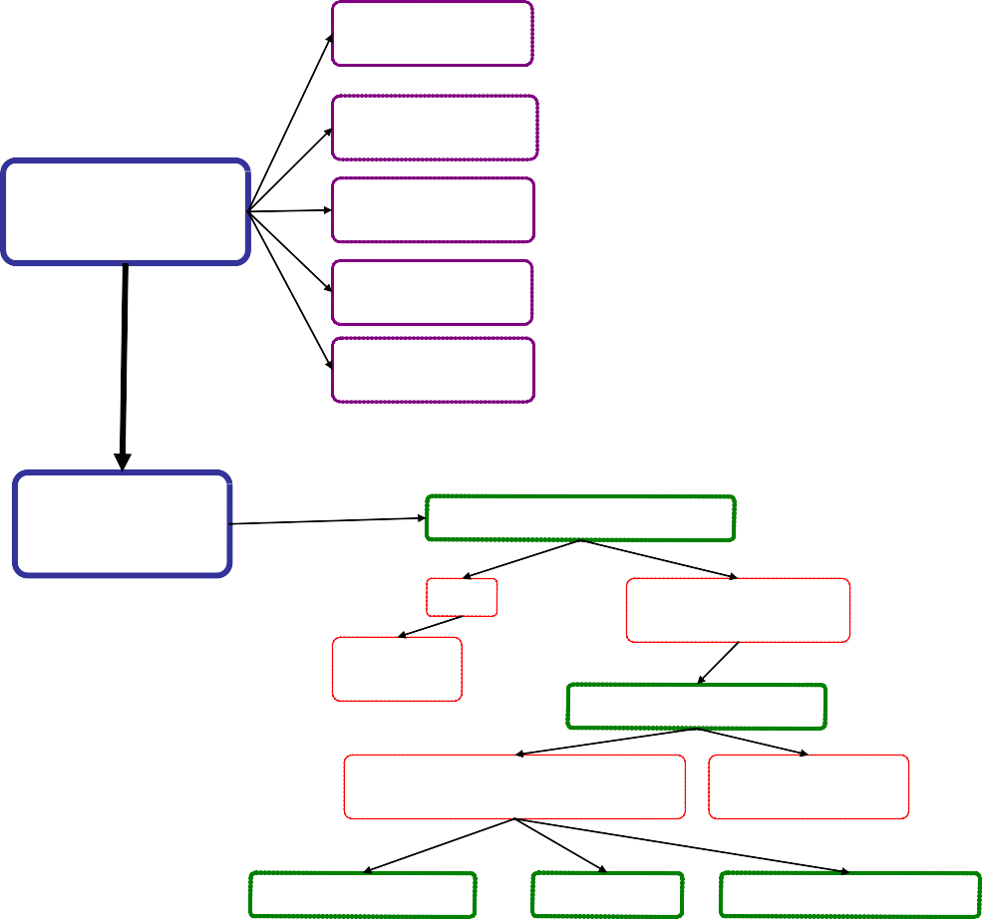What is the aim of the review?

A practice aims to improve the safety of patients prescribed anticoagulants.

  - Plan and prepare

What data should be collected?

Sampling: size and method?

Triggers: number and type?
The team agrees to record the number of triggers and patient safety incidents for the last three months.

Twenty five records w ill be randomly selected from the register of patients that meet the inclusion criteria.

Seven triggers are chosen (Box 1). ‘Additional trigger ‘INR >5 is added.

Individual and Team responsibilities?
The practice nurse will conduct the preliminary review . Detected PSIs will be verified by a named GP. An administrator will code the data.

Review records

Can triggers be detected?

No

Review the next record

Yes. For each detected trigger, consider:

Did a PSI occur?

Yes. Summarize the incident and judge three characteristics:
No. Continue to next trigger or record

Severity?
Origin?
Preventability?

Patient and medical records
•Acknowledge PSI and apologize to patients, where necessary
•Consider audits to detect similar events
•Consider improvements to prevent recurrence of similar incidents.

Reflection, further action

Practitioner level

Practice team
•Identify personal learning needs for improvement, appraisal and governance

•Share findings with the team
•Discuss and reflect on findings
•Prioritize improvement efforts according to detected PSIs

Primary-secondary care interface
•
Consider appropriate feedback
•Consider incident reporting through local and national systems
•Consider a joint SEA

Step One: Planning and Preparation
Appendix 2: The trigger tool data collection proforma

Please complete:
Name of Reviewer: | 1 |  | Name of Practice | 3
Date of Review | 2 |  | Profession (please circle) | GP Principal – GPST - Sessional GP - Salaried GP - Practice Nurse
No. of Records Reviewed | 4 |  | Review Period  (e.g. 3-months) | 5
What Patient Group did you select records from? | 6

Step Two: Review of Records

Please aim to review 25 records from the chosen patient group. Tick one box () next to each trigger each time you find it in one of the records. (7)

Trigger  (A ‘prompt’ that may indicate a safety incident) |  |  |  |  |  |  |  |  |  |  |  |  |  |  |  |  |  |  |  |  | Total
≥3 consultations in 7 days 8
New ‘high’ priority read code added 9
New allergy read code added 10
‘Repeat’ medication item discontinued 11
Out of Hours/A&E attendance 12
Hospital admission 13
Hb <10.0 14
eGFR reduction ≥5 15
Optional trigger: 16

REVIEW FINDINGS:
Please briefly describe the patient safety incidents that you detected. Next, judge the severity and preventability of each incident using the scales below and then add the two scores in the ‘priority’ column.

Description of Detected Patient Safety Incidents 17 |  |  |  |  | Severity | Preventability | PRIORITY 18
+ =

+ =

+ =

+ =

+ =

Severity Scale: |  |  | Preventability Scale:
1 | Any incident with the potential to cause harm |  | 1 | Not preventable and originated in secondary care
2 | Mild harm: inconvenience, further follow-up or investigation to ensure no harm occurred. |  | 2 | Preventable and originated in secondary care OR not preventable and originated in primary care
3 | Moderate harm: required intervention or duration for longer than a day |  | 3 | Potentially preventable and originated in primary care
4 | Prolonged, substantial or permanent harm, including hospitalization |  | 4 | Preventable and originated in primary care
Patient Safety Incident:
“Any incident that caused harm, or could have caused harm to a patient as a result of their interaction with health care”
(The definition encompasses error, harm, adverse event, significant event and near miss)

Step Three: Reflection, Action & Improvement

A. Please describe any Actions/Improvements made DURING the review (e.g. updated coding or prescribing)
19

B. What do you plan to do NEXT as a result of the trigger review findings?
(Use PRIORIITY scores to guide you - tick as appropriate)

Specific actions 20 |  |  |  |  |  | Please describe: 21
Significant event analysis
Audit
PDSA Cycle
Feed back to colleagues
Make a specific improvement(s)
Add to Appraisal documentation
Discuss with Educational Supervisor
Update or develop a protocol
C. Please describe identified Personal, Professional or Practice Team Learning Needs: 22
Personal:

Professional:

Practice Team:

Please add any comments about the trigger review process:
23

Finally, approximately what length of time (in minutes) did it take you to review all records? |  |  |  |  |  |  | 24 mins.
Appendix 3

How to complete the Summary Report

Planning & Preparation etc

- Indicate the total number of reviewed records in this box. Once you have detected five patient safety incidents you do not need to review any more records.
- The suggested maximum number of records to review is 25, even if you have still not detected five patient safety incidents.
- The review time period is the number of full calendar months that you reviewed in each record. The same calendar months should be reviewed in each record.
- The usual number of months is three, although some reviewers may decide to review a longer period.
- To allow relevant correspondence to return from other health care colleagues, we suggest you allow at least a month after the review period and the date of review.
- The rationale for choosing a specific sub-population of patient records to review is that it increases the likelihood of detecting patient safety incidents. There is no single ‘correct’ group to choose. Examples of potential ‘high risk’ patient sub-groups are provided in the appendix.

Review of Records

- Tick one box each time you find a trigger in the record. Some triggers may occur more than once.
- If triggers detected examine the relevant section of the record in more detail to determine if the patient came to any form of harm. The majority of detected triggers will not be linked to harm incidents.
- Describe each detected patient safety incident in sufficient detail so that others can understand exactly ‘what happened’ and ‘why it happened’ if this is immediately apparent.
- Subjectively ‘Priority Score’ each patient safety incident by combining the severity and preventability scores. This is intended to help prioritize the order in which patient safety incidents are considered for action in ‘Step Three’ e.g. incidents with higher scores should arguably be a priority, although this remains at the discretion of the reviewer.
- If evidence of harm is detected, the reviewer should consider where it originated, the severity level and judge perceived preventability.
- If no harm is detected, the reviewer should continue reviewing the record or commence with the next record if applicable. When reviewers are uncertain whether harm occurred they should not record the incident.

Reflection Action and Improvement

- During record reviews ‘action’ is often taken e.g. amending, adding or removing prescribed items; adding or amending clinical codes; recording entries or arranging for recommendations from other health care settings to be implemented; arranging further investigations, appointments or referring for further treatment. Please briefly document these types of actions in the box provided.
- The clinician or practice team should share and collectively reflect on the review findings as part of routine educational or business meetings.
- The team should consider how they can prevent or reduce harm and improve care quality.
- Different improvement methodologies are available include Significant Event analysis, clinical audit and PDSA cycle which may be considered by their practice team to analyse the incident further and or make improvements.
- A list of possible further actions is outlined. Please tick one box each time you plan to take that specific action.
- Please provide a detailed summary in this section about any other action you intend to take.
- Please describe any learning needs (personal, professional, team-based or interface issues) you considered or identified during the review process, where applicable.
- It may also be useful and necessary to share specific findings with relevant stakeholders, for example the health board other practices the OOH services or secondary care.

The report can be used for evidence for appraisal and revalidation and may be shared with your HB as evidence of fulfilling contractual requirements

