Joint NHS Ayrshire & Lanarkshire

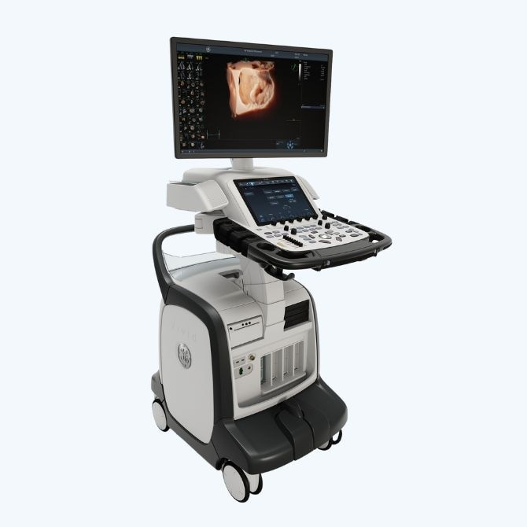

FUSIC Heart Course

Friday 25th October 2024
University Hospital Hairmyres

Course cost £230

This course is validated by RCOA/FICM for 5 CPD points

Teaching from cardiologists, BSE accredited sonographers and FUSIC accredited intensivists

To apply for the course, please email isobel.kirby@lanarkshire.scot.nhs.uk

