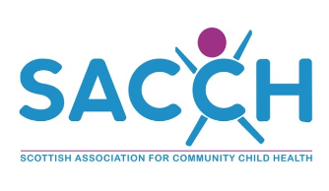

SACCH Annual conference and agm
Topic: Clinical Updates for the Community Paediatrician
Friday 25th April | 08.30am – 05.00pm
STEP, Stirling Enterprise Park, Players Road, Stirling, FK7 7RP

BOOK HERE

Agenda
08.30 – 09.00 | Registration
09.00 – 09.05 | Welcome and Opening Remarks | Dr Alison McLuckie, SACCH Chair
09.05 – 10.05 | Dental Health in Children with Disability | Dr Mary Skene, NHS Lothian Oral Health Service
10.05 – 11.05 | Genetics - Underpinnings, Indications and Limitations of the Trio Exome | Dr Jamie Campbell, NHS Lothian
11.05 – 11.30 | Coffee
11.30 – 12.30 | Could this child have a metabolic disorder? Investigations - What, Why and When? | Dr Paul Smith, NHS Greater Glasgow and Clyde
12.30 – 1.30 | Lunch and SACCH AGM
1.30 – 2.30 | Nutritional Considerations for the Neurodisabled Child and Other Children seen in Community Paediatrics | Dr Su Bunn, NHS Grampian
2.30 – 3.30 | Child Death Reviews | Alison Rennie, NHS Greater Glasgow and Clyde
3.30 – 3.45 | Coffee
3.45 – 4.345 | Neuroaffirming Approach and Practice | Dr Marion Rutherford, NAIT
4.45 – 4.50 | Closing Remarks | Dr Alison McLuckie, SACCH CHair

BOOK HERE

