Scotland Deanery Newsletter
Issue 51 | August 2025

Content

- Foreword
- How to Thrive as a New Resident Doctor in Scotland
- GMC National Training Survey Results
- New to Training in Scotland?
- Death Certification – Launch of New E-Learning Modules
- Routes to Impactful Knowledge: Transforming Ideas into Action
- Bereavement Education Conference & Learning Event
- Valuing Diversity and Promoting Inclusivity
- Please Contact Us
- NES Websites and Social Media

- Foreword

Welcome to the August edition of the Deanery newsletter.

Welcome to the new training year and the August edition of your Deanery newsletter. We have a bumper newsletter this month as we try to ensure we cover things that will be useful to new starts – new graduates, new to the UK, new to Scotland or new to a training programme. We hope that there are articles of interest to those who are now feeling well established in training and for our trainers too.

First of all, we have details of the series of resident doctor webinars hosted by the NES Medical Senior Team. All resident doctors are invited. The weblink gives you access to the recording of the webinar and Q&As from the events. The next webinar will be in late August and all resident doctors will receive an invite.

Secondly, we have a really informative article written by a resident doctor. This item gives you tips and information to help you in the first, or subsequent years of your training.

Next, we have a round up of the GMC National Training Survey results for Scotland. This annual survey gives the Deanery much needed information from our resident doctors to help with current issues and with shaping future improvements.

“In a number of programmes, Scotland was ranked 1st in the UK.”

Thanks to everyone that took part.

There’s more information for those new to training in Scotland. The article introduces new trainees to some of the extensive trainee resources available on the Scotland Deanery website Scotland Deanery | NHS Education for Scotland | NES. These include information on Study Leave, for International Medical Graduates and who your NES Training Programme Administrator is and how to contact them.

The NES Bereavement Education Programme has recently launched two e-Learning modules on death certification in collaboration with colleagues at the Death Certification Review Service. The next item explains it all and is excellent information for resident doctors.

After this the NES Knowledge Services team invites you to join their week-long event starting 1st September 2025. This event aims to facilitate learning, collaboration and the sharing of knowledge across boundaries and hierarchies. Hope you find some time to join.

Lastly, there’s news on the Bereavement Education Conference & Learning Event on Tuesday 11th November. You can register now for ‘Bereavement as a Kaleidoscope: An Inclusive Approach for All’.
Remember to keep submitting articles or suggestions for content, take care and take breaks.

I hope you enjoy this edition.

If you have work you would like to highlight in this newsletter, contact Scotland Deanery.

Professor Emma Watson
Executive Medical Director, NHS Education for Scotland

- How to Thrive as a New Resident Doctor in Scotland

Congratulations on your new post as a doctor in Scotland!

It may have been your dream to work here, or it may have been an unexpected move, but we are really pleased to have you here.

This article is a list of things which you may find helpful whilst starting out with your new work in NHS Scotland.

The NHS Education for Scotland (NES) Scotland Deanery website has more guidance on living and working in Scotland www.scotlanddeanery.nhs.scot and www.scotmt.scot.nhs.uk/living-in-scotland/.

It also has more help for International Medical Graduates (IMGs) www.scotlanddeanery.nhs.scot/international-medical-graduates/ and www.scotlanddeanery.nhs.scot/international-medical-graduates/preparing-for-life-in-scotland-new-to-nhs-scotland/.

Contracts

If you have not already received your contract, you should do so in the next few weeks. Usually this comes from your employing or lead health board; if you don’t receive it, you should contact your human resources (HR) representative. It is important you read through and understand your contract. Most contracts for resident doctors are based on a model contract, but subtle differences do occur between health boards. The British Medical Association offer their members a service to check their contracts and advise on any variations in it.

Understanding Pay

Pay for resident doctors in Scotland is set by the Scottish Government. Resident doctors are paid a base salary dependent on years of NHS service/ experience and grade www.bma.org.uk/pay-and-contracts/pay/resident-doctors-pay-scales/pay-scales-for-resident-doctors-in-scotland. Depending on your role or rotation, you may be paid a supplemental uplift known as banding if you work more or more antisocial hours. This is paid as an additional percentage of your base salary.

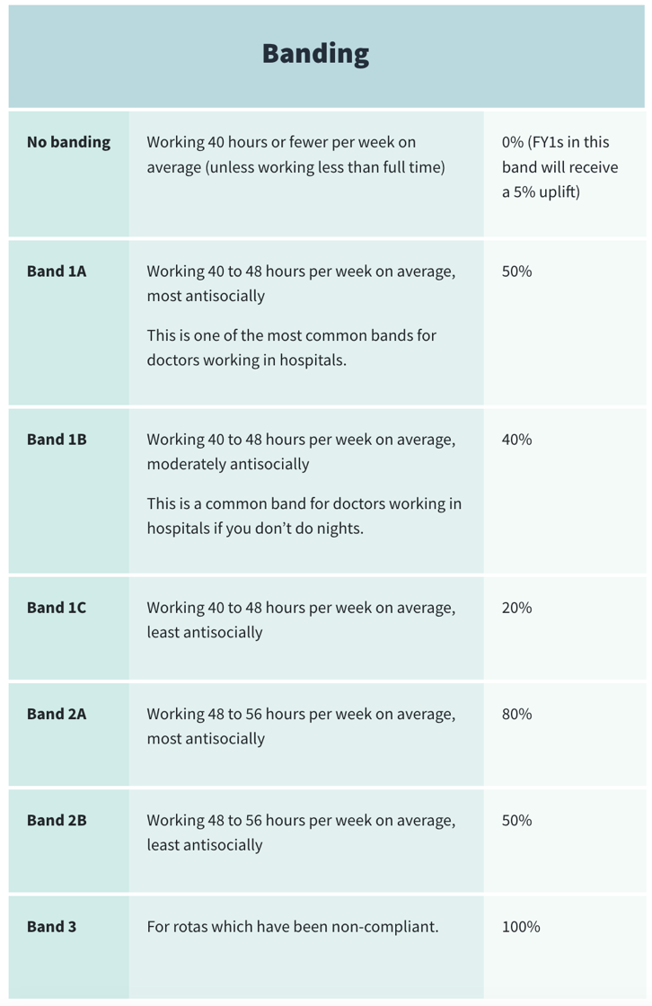

Buying or renting a house

Finding somewhere nice to live is one of the most difficult and important parts of moving for a new job. The rental market in parts of Scotland can be very competitive. If you are struggling to find somewhere, it is worth asking your colleagues as some people will let out rooms. You can also find Facebook groups or use websites like Spare Room www.spareroom.co.uk.

If you are renting and the owner doesn’t live in the property, make sure they are registered on the landlord register https://landlordregistrationscotland.gov.uk and that your deposit is protected by a deposit protection scheme www.gov.scot/policies/private-renting/tenancy-deposit-schemes/. Shelter Scotland has more information on your rights when renting https://scotland.shelter.org.uk/housing_advice/tenants_rights.

Buying a house in Scotland is a slightly different process to elsewhere in the UK. Most properties are listed as an offers over price, have a home report (survey) which has an estimated value, and can typically sell for 5-15% over this home report value. This extra money must come from cash, as a mortgage will only cover the home report value. Finding a property which is on sale for a fixed price or a new build can be a workaround for this. You can use your contract or 3 months’ payslips as proof of income for a mortgage. It is worth making an appointment with a mortgage advisor rather than a bank first https://scotland.shelter.org.uk/housing_advice/housing_options/buying/mortgage.

Relocation expenses

Depending on your circumstances, you may be eligible for relocation expenses of up to £8,000 from your lead employer. The amount you are eligible varies on whether you are moving between rental properties or buying and selling a property and must be because you are relocating within 6 months of starting your new job. You should contact your human resources department to ask for more information on this.

Turas

NHS Education for Scotland runs the Turas website https://turasdashboard.nes.nhs.scot which is an essential tool to all resident doctors in Scotland. It is important.

Training Portfolio

It is well worth getting to know this section of Turas well if your training programme uses it (such as the Foundation Programme). This is where you will have to gather evidence of meeting your programme curriculum requirements and submitting supervised learning events (SLEs) and recording evidence of teaching and other core and non-core learning.

People

Turas People acts as a link between a resident doctor and their lead employer and placement board. Here you can download proof of employment, your contract and any other important files in the ‘Filing Cabinet’. It will also show details of your training programme, current and next placements. There are staff engagement, occupational health, and fitness to practice forms which are mandatory to fill out.

Learn

The Turas Learn section has a bank of resources and learning modules covering a range of topics. It can also be used to book and manage courses.

Scottish Online Appraisal Resource (SOAR)

SOAR is a website used for doctors beyond foundation training as a tool for annual appraisal and ARCP. If you need to use it, you will receive further guidance on it nearer the time.

The Mental Health Act (2003) and the Adults with Incapacity Act

If you are new to working as a doctor in Scotland, these are key pieces of legislation to understand, particularly if you are working as an FY2 or above. The Mental Health Act relates to the detention of someone with a suspected mental disorder e.g an emergency detention certificate and differs to the rest of the UK. The Adults with Incapacity Act relates to providing medical treatment to those who do not have capacity under an ‘Adults with Incapacity (AWI)’ form. It is well worth doing an eLearning module on these and this will meet the foundation programme curriculum requirements.

Ralph Shackleton
CT2 Anaesthetics, WoS

- GMC National Training Survey Results

Each year the GMC run their National Training Survey to gather feedback on trainees training experience across the UK. This year we are very pleased to share some feedback from the survey which highlights a number of training programmes within Scotland ranked 1st in their programme groupings for overall satisfaction. Some of the rankings are for our regional programmes whilst others are for Scotland as a whole. Further information on the survey data can be obtained on the GMC website. The total number of programmes used for the UK ranking relates to programmes that received more than 3 responses. There may be more programmes across the UK than reflected in that total. Overall satisfaction for training in Scotland sees NHS Education for Scotland rank 4th out of 18 deaneries.

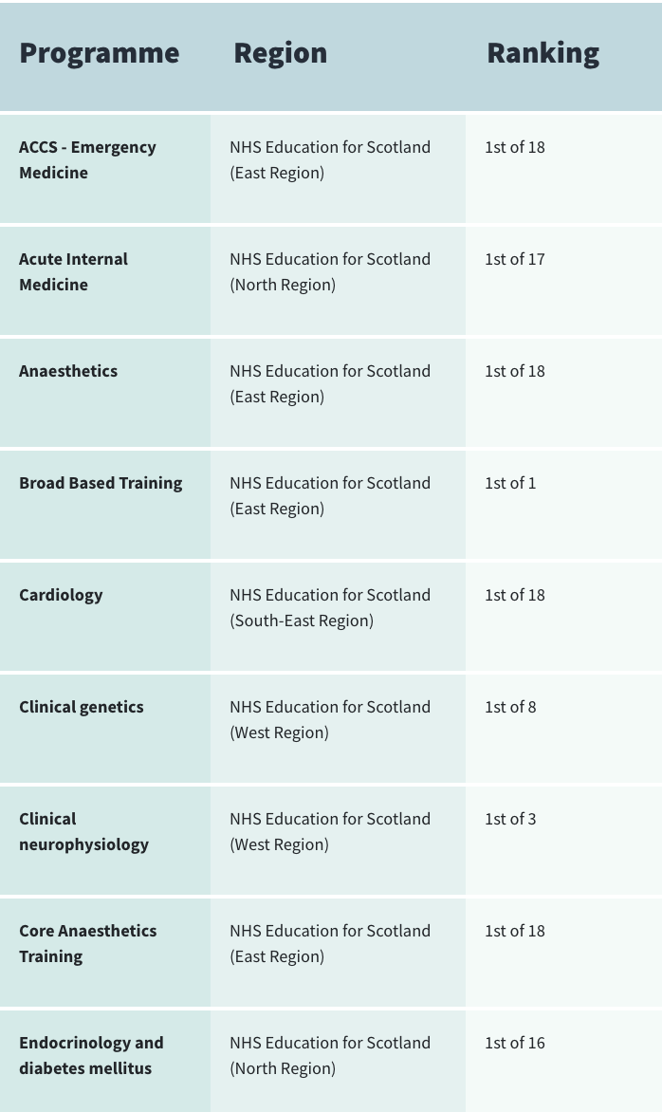
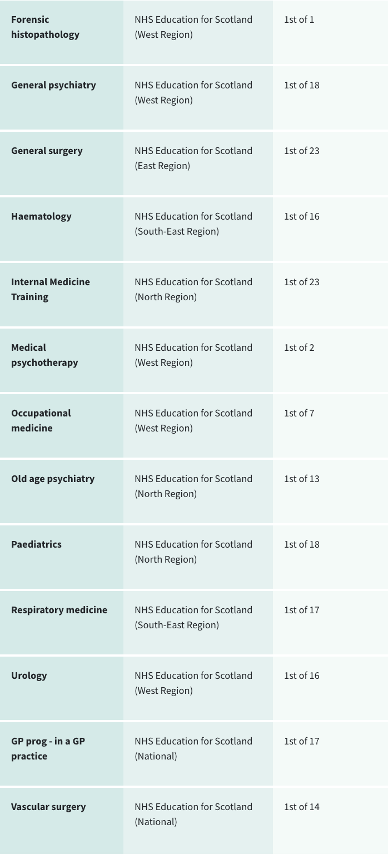

- New to Training in Scotland?

Welcome to medical training in Scotland!

We hope that you will enjoy your time here. The Scotland Deanery website www.scotlanddeanery.nhs.scot is an essential resource which provides you with useful contacts and information in relation to your training.

For example:
- Who is your NES Training Management Administrator? scotlanddeanery.nhs.scot/about-us/our-people/training-management-team/
- Specific suites of pages in relation to Foundation Training Scottish Foundation School | Trainee Information (nhs.scot)
- Advice and guidance for International Medical Graduates International Medical Graduates (IMGs) (nhs.scot)
- How to apply for Study Leave Study Leave | Scotland Deanery (nhs.scot)
- Study Leave for Foundation Doctors Study Leave in Foundation (nhs.scot)
- What you need to know about your Annual Review of Competence Progression (ARCP) Annual Review of Competence Progression (ARCP) | Scotland Deanery (nhs.scot)
Advice and guidance on your options for:
- Less Than Full Time Training Less Than Full Time Training | Scotland Deanery (nhs.scot)
- Out of Programme Out of Programme (OOP) | Scotland Deanery (nhs.scot)
- Transfers (Inter deanery) Transfers | Scotland Deanery (nhs.scot)
- How to Report a Concern Report a Concern | Trainees | Scotland Deanery (nhs.scot)
- Advice and guidance in relation to Recruitment Recruitment | Scotland Deanery (nhs.scot)

We also have a Trainee Development and Wellbeing Service which can offer you support on a range or topics including exams, career advice, work adjustments, wellbeing, ARCP guidance, & more. The service offers confidential, non-judgmental support and can be accessed by all doctors in training in Scotland at any point in their training journey www.scotlanddeanery.nhs.scot/trainee-development-and-wellbeing-service/



Feedback is always welcome in relation to the Deanery – if you have any suggestions or comments please contact us Contact the Scotland Deanery (nhs.scot)
- Death Certification – Launch of New E-Learning Modules

The NES Bereavement Education Programme has recently launched two e-Learning modules on death certification in collaboration with colleagues at the Death Certification Review Service.

The 'Certification of Deaths in the Community' module will help to decide the appropriate next steps when dealing with a death in the community.

The module will help learners understand:
- When to report a death to the procurator fiscal service.
- When to issue a medical certificate of cause of death (MCCD).
- Potential issues when communicating with the police.

The 'Improving the quality of medical certificates of cause of death: Avoiding errors' module focusses on reducing many of the common errors that are found on MCCDs in Scotland.

The module will help learners understand e.g., the:
- Correct completion of all parts of the MCCD
- Acceptable use of abbreviations
- Requirement of duration intervals
- Requirement to inform of the presence of hazards
- Requirement to report a history of accident or trauma to the procurator fiscal

Access the modules on Turas Learn.
Other bereavement-related educational materials can be found on the NES Support Around Death website.

- Routes to Impactful Knowledge: Transforming Ideas Into Action

Join NES Knowledge Services for our week-long event starting 1st September 2025!

This event aims to facilitate learning, collaboration and the sharing of knowledge across boundaries and hierarchies. Expand your horizons, connect with colleagues, exchange ideas and unleash your knowledge sharing potential for yourself, your teams and your organisations.
This series of nine sessions will introduce you to the concepts of knowledge management and provide opportunities to try various knowledge management techniques in a supportive environment. Everyone is welcome!

- Session 1: Introduction to knowledge management or the power of a good conversation
- Session 2: Getting started with knowledge management techniques
- Session 3: Knowledge brokers: connecting you to trustworthy sources
- Session 4: Knowledge brokers: building your networks
- Session 5: Connecting you to the information you need: a day in the life of a knowledge manager
- Session 6: A lunch and learn journey: before and after action reviews
- Session 7: Liberating structures part 1: facilitating a large group versus breakout rooms
- Session 8: Liberating structures part 2: breakout room techniques
- Session 9: Meet the experts: a conversation about communities of practice

Register now for all or any of the sessions you are interested in attending Book your place

For further assistance, please contact Knowledge Services Help Desk

- Bereavement Education Conference and Learning Event

Bereavement Education Conference 2025 - Bereavement as a Kaleidoscope: An Inclusive Approach for All

Tuesday 11th November

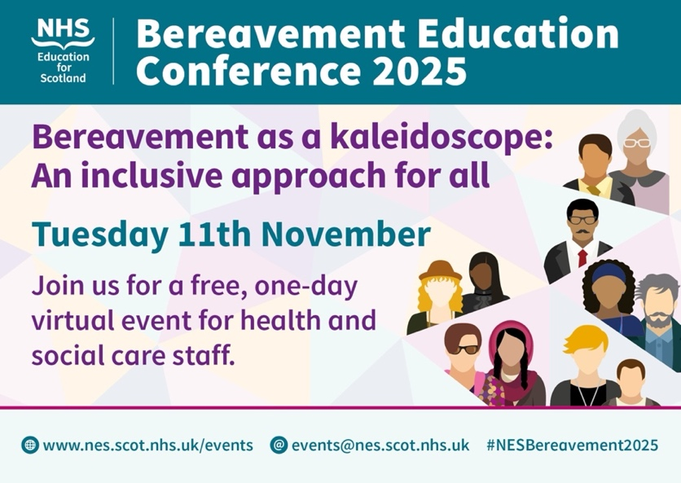

NES would like to welcome you to the 2025 Bereavement Education Conference which is a free one-day virtual event for health and social care staff. Plenary and parallel sessions will run throughout the day.
We’re delighted to announce Helen Fielding as a key speaker. She is author of the ‘Bridget Jones Diary’ series, including the recent screen adaptation of ‘Mad About the Boy’ which includes a focus on the title character’s experience of bereavement. We’ll also be hearing from Professor Lucy Easthope (Centre for Death and Society, University of Bath), in her plenary ‘Come What May: Learning from a Life in Disaster’.

Other topics that will be explored include e.g.:
- Is Everyone a Loved One? Social Science Explorations of Bereavement
- Prolonged Grief Disorder: What Is It, and How Can I Help?
- Pre-bereavement Support for Children and Families in Palliative Care
- Equitable Bereavement Care for all Ethnicities
- Silenced Trauma, Unresolved Loss: Creative Health to Bear Witness to Families of the Missing
- Supporting LGBTQ+ people around bereavement
- Hospital to Home – a Collaborative Approach to Bereavement Support

Registration is now open. Visit the conference website to find the full programme, parallel session information and registration link.
Virtual Learning Event - Getting Bereavement Right Every Time

Thursday 11th September

Sign up now to attend this 2-hour learning session which will provide an introduction to grief and bereavement. Knowing how to manage situations around the time of a person’s death, and interactions with those who are bereaved is important so that we can help and support others, whilst also looking after our own wellbeing. But thinking of what to say to someone who is bereaved (e.g. a family member, patient, or colleague) may feel daunting.

This session will help attendees feel more confident in answering questions e.g.:
- What should I say to someone who tells me they have recently been bereaved?
- Are there particular words I should or shouldn’t use?
- What if I say the ‘wrong’ thing?
- Is it normal to be upset if someone we know from work dies?

If you have any queries about the November conference or September Learning Event please contact Events@nes.scot.nhs.uk.
]
8. Valuing Diversity and Promoting Inclusivity

Inclusivity Poster

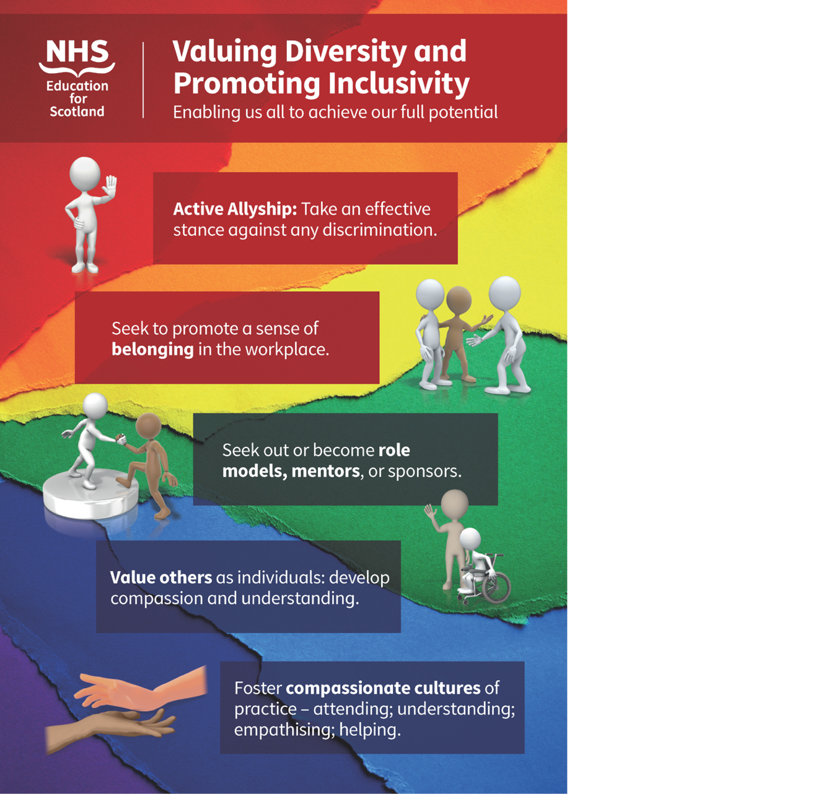

9. Please Contact Us

FAO All Resident Doctors in Training
Please contact us with information on any initiatives and projects you are involved in that you would like to share with your colleagues across Scotland, or if you have feedback on the Deanery Newsletter or Deanery Websites.

10. NES Websites and Social Media

NES Facebook
You can follow NES on Facebook here:
NHS Education for Scotland (NES) | Edinburgh | Facebook
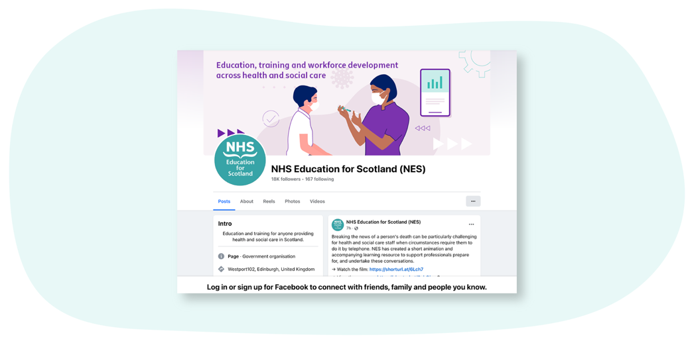
The Scotland Deanery Website
On the Scotland Deanery website for Scottish medical training there are sections with lots of relevant information for resident doctors in training, trainers, IMGs, Medical ACT, Quality and the Trainee Development and Wellbeing Service.

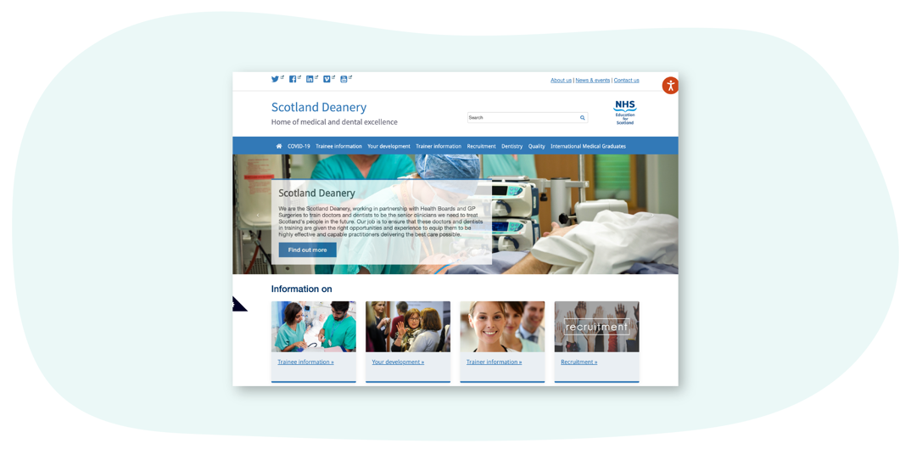

Scottish Medical Training
This site is our recruitment site and is the principal resource to learn more about how to apply for Foundation, Core and Specialty Medical Training in Scotland. Here you’ll find regularly updated information about application windows (how and when to apply), a directory of 50+ GMC-approved medical specialty programmes and first-hand accounts about training from resident doctors in training and trainers. There are also useful insights on career direction and what it’s like training and working in Scotland.

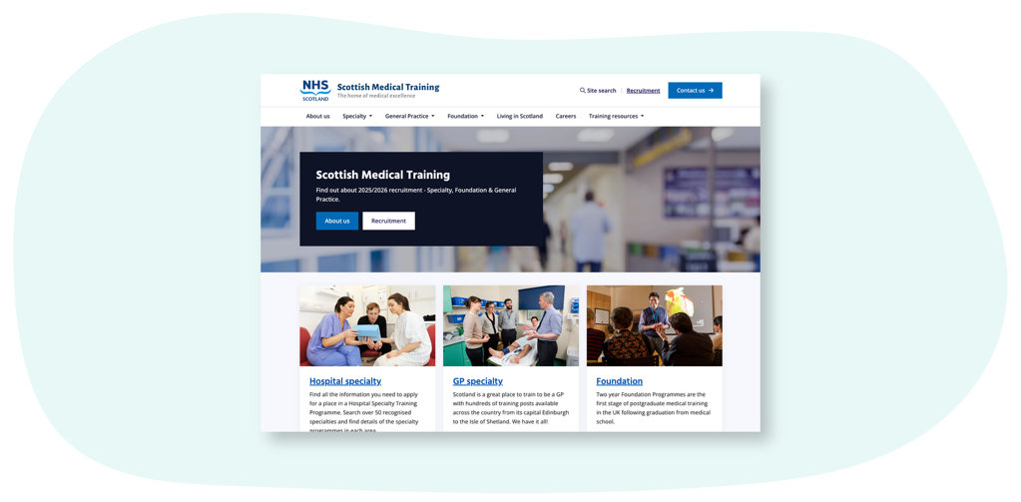

Scottish Online Appraisal Resource (SOAR)
Designed for doctors (in both Primary and Secondary Care) working and training in Scotland, for their Appraisal and Revalidation needs. The Scottish Online Appraisal Resource (SOAR) is used by Appraisers and Appraisees to aid the appraisal process, and for resident doctors in training to complete their self-declarations. Here you’ll also find a SOAR user guide, handy FAQ’s and examples of Quality Improvement Activities.

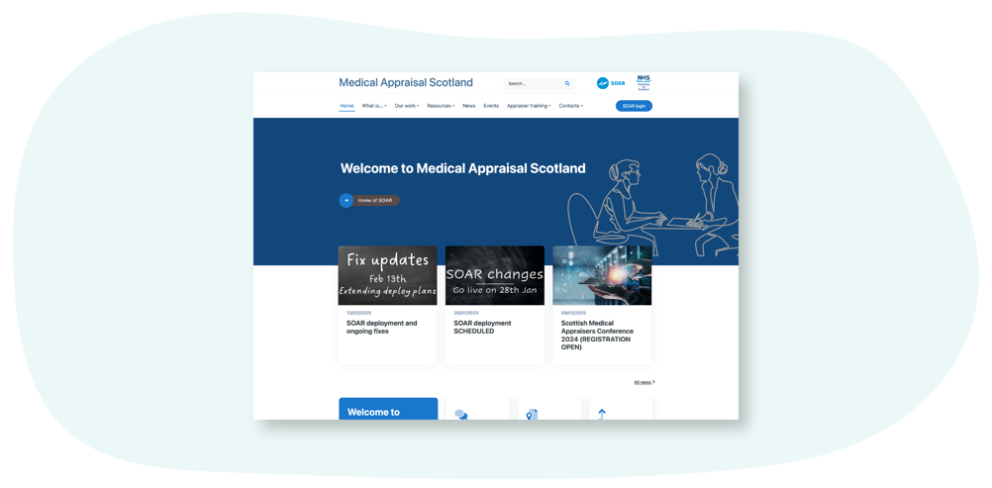

Clinical Skills Managed Educational Network (CSMEN)
This website provides information and resources relating to the Clinical Skills Managed Educational Network (CSMEN) which was established in 2007 to support excellence in clinical skills education.
The focus has been on improving patient safety and clinical outcomes by supporting access to high quality, multi-professional skills training and clinical simulation across all geographical areas of Scotland.
CSMEN develops online educational resources, manages and deploys a Mobile Skills Unit (MSU) which provides state of the art simulation facilities for remote and rural healthcare practitioners and has built a national network of healthcare educators and practitioners.
We connect people and organisations involved in health and social care to enable collaboration for a "Once for Scotland" approach to skills and simulation-based learning.
